

SCHOOL OF COMPUTER SCIENCE
AND ARTIFICIAL INTELLIGENCE
DEPARTMENT OF COMPUTER SCIENCE

Assignment Type: Lab
Academic Year:2025-2026
Course Coordinator Name:- Dr. Rishabh Mittal
STUDENT NAME:-Pentapuri yeshwanth
ENROLLMENT NUMBER:-2403A51l39
SUBJECT NAME:- AI Assisted Coding
COURSE CODE:-23CS201PE401
YEAR/SEM :- III/II
BATCH:-52

TASK
Assignment submission starts from here

Lab 13: Code Refactoring – Improving Legacy Code with AI

Task Description 1 (Refactoring – Eliminating Repetitive Logic)
length = 8
width = 4
print("Area:", length * width)
print("Perimeter:", 2 * (length + width))
length = 12
width = 6
print("Area:", length * width)
print("Perimeter:", 2 * (length + width))
Prompt:- Analyse the given Python code and identify repeated calculations. Refactor the program by creating a reusable function to compute the area and perimeter of a rectangle. Ensure the program output remains the same and add proper docstrings to the function for clarity and maintainability.
CODE:-
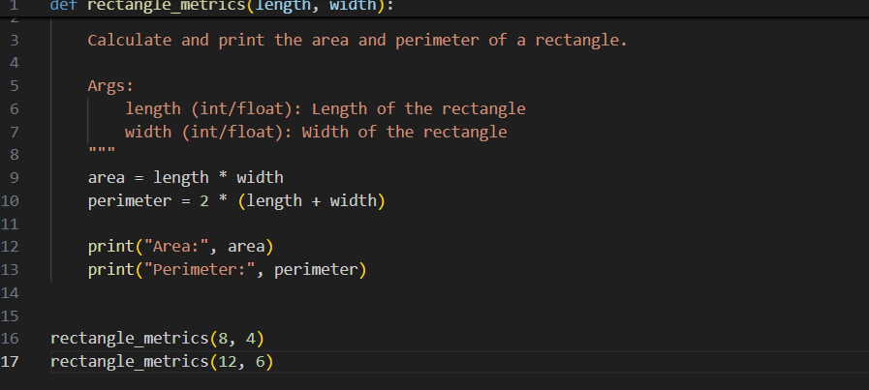

OUTPUT:-

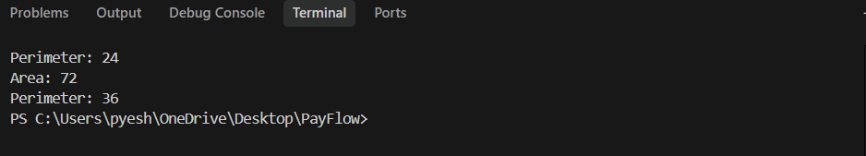
Explanation (Key Points)
- Identify repetition: The original code repeats the same area and perimeter calculations.
- Create a function: A reusable function is created to handle these calculations.
- Use parameters: The function takes length and width as inputs.
- Avoid duplication: Instead of rewriting formulas, the function is called multiple times with different values.
- Add docstring: A docstring explains the purpose of the function and its parameters.
- Same output: The refactored program produces the same results as the original code.
Logic
- Define a function to calculate area and perimeter.
- Use formulas: area = length × width and perimeter = 2 × (length + width).
- Print the results inside the function.
- Call the function with different values like (8,4) and (12,6).

Task Description -2 (Refactoring – Modularizing Inline
Calculations)
Task: Use AI to refactor a Python script by extracting repeated
inline calculations into reusable and well-documented functions.
Sample Code:
amount = 1000
discount = amount * 0.10
final_amount = amount - discount
print("Final Amount:", final_amount)
amount = 2000
discount = amount * 0.10
final_amount = amount - discount
print("Final Amount:", final_amount)

Prompt:- Analyse the given Python script and identify repeated inline calculations.
Refactor the code by extracting the repeated logic into a reusable function.
Ensure the program remains readable, modular, and produces the same output.
Add proper docstrings explaining the function's purpose and parameters.

CODE:-

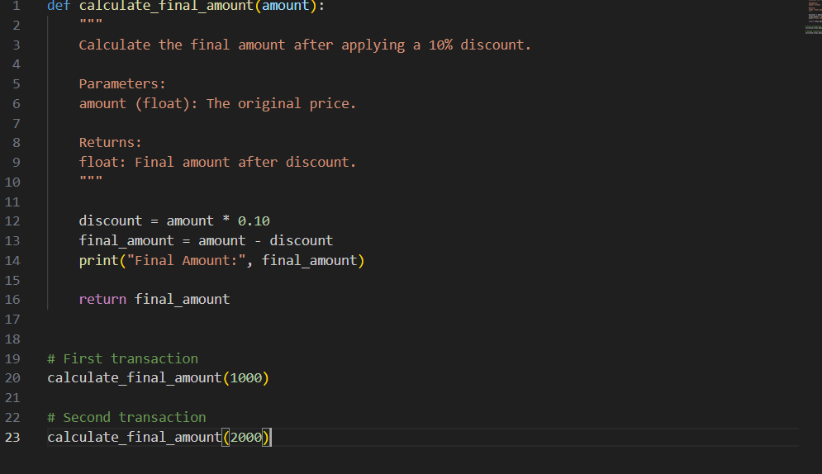

OUT PUT:-
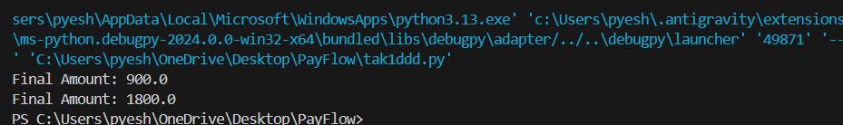

Explanation
The original program repeats the same discount calculation for different amounts.
To improve the code, the repeated logic is placed inside a function called calculate_ final_ amount().
This function:
- Takes the amount as input
- Calculates 10% discount
- Computes the final amount
- Prints the result
By calling the function with different values, the program avoids repeating the same code.

5. Key Points
- Repeated calculations identified: Discount and final amount formulas.
- Function created: calculate_ final_ amount() to reuse the logic.
- Parameters used: Amount is passed as input to the function.
- Code modularised: Logic is written once and reused.
- Docstring added: Explains the function's purpose and parameters.
- Same output maintained: Program results remain unchanged.

6. Program Logic
- Define a function calculate _ final _amount(amount).
- Inside the function calculate
  - discount = amount × 0.10
- Calculate final price
  - Final _amount = amount - discount
- Print the final amount.
- Call the function with different values (1000, 2000).

Task Description -3 (Refactoring – Improving Loop and
Conditional Performance)
• Task: Apply AI-based suggestions to enhance the performance of
Python code that relies on nested loops and repeated conditional
checks.
Sample Code:
students = ["Anil", "Bhavya", "Charan", "Divya"]
check_list = ["Charan", "Esha", "Bhavya"]
for name in check_list:
exists = False
for student in students:
if name == student:
exists = True
if exists:
print(name, "found")
else:
print(name, "not found")
Prompt:- Analyze the given Python program that uses nested loops and repeated conditional checks for searching names in a list. Identify performance issues and suggest improvements using more efficient data structures or simplified logic. Refactor the program to improve lookup speed while keeping the output the same. Compare the execution performance before and after refactoring and ensure the code is well structured and readable.

CODE:-

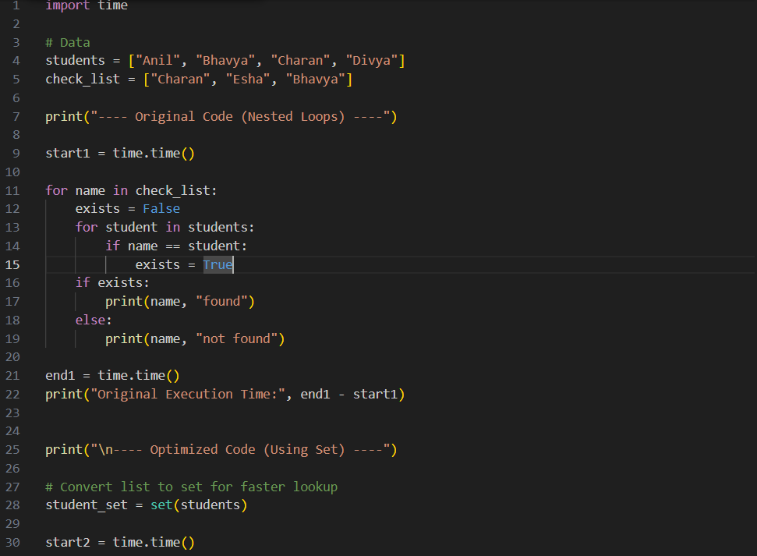

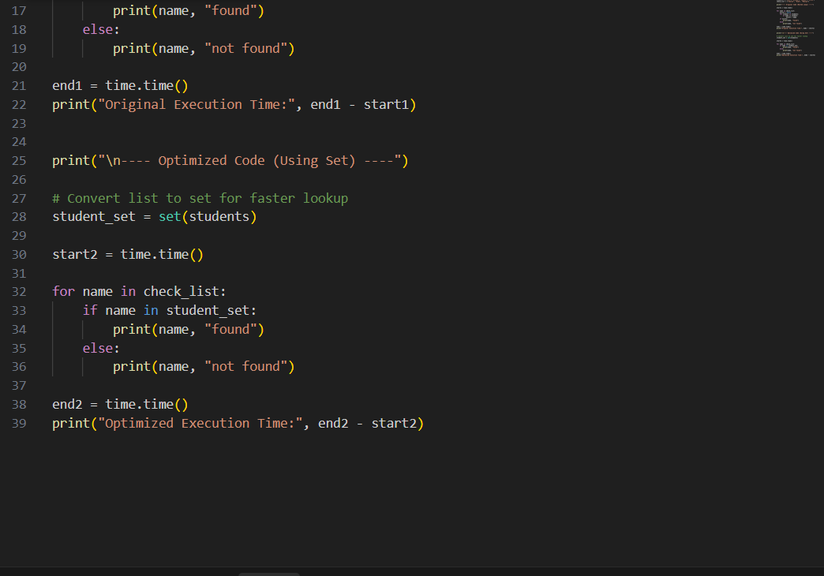

OUTPUT:-
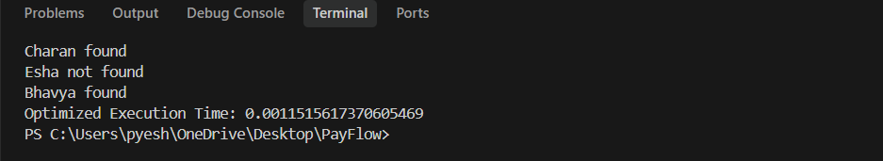

Explanation
The original program checks whether each name in check_list exists in the students list using nested loops.
For every name in check_list, the program scans the entire students list. This increases execution time when the list becomes large.
To improve performance, the optimized version converts the students list into a set.
A set allows faster searching using the in operator, which avoids the need for nested loops. This reduces the time complexity and makes the program more efficient.
The program also measures execution time using the time module to compare the performance of the original and optimized versions.

Key Logic
- Store student names in a list called students.
- Create a check list containing names to search.
- Original Method:
  - Use nested loops to compare each name with every student.
  - If a match is found, mark it as exists = True.
- Optimized Method:
  - Convert students list into a set for faster lookup.
  - Use if name in student_set to check existence.
- Measure execution time before and after optimization.
- Print results showing whether each name is found or not.

Task Description -4 (Refactoring – Replacing Hardcoded Values
with Constants)
• Task: Utilize AI assistance to improve maintainability by
replacing hardcoded numerical values with named constants.
Prompt:- Analyse the given Python program and identify hardcoded numeric values used directly in calculations.
Refactor the code by replacing these values with descriptive named constants defined at the beginning of the program.
Ensure the program output remains the same while improving readability and maintainability.

CODE:-
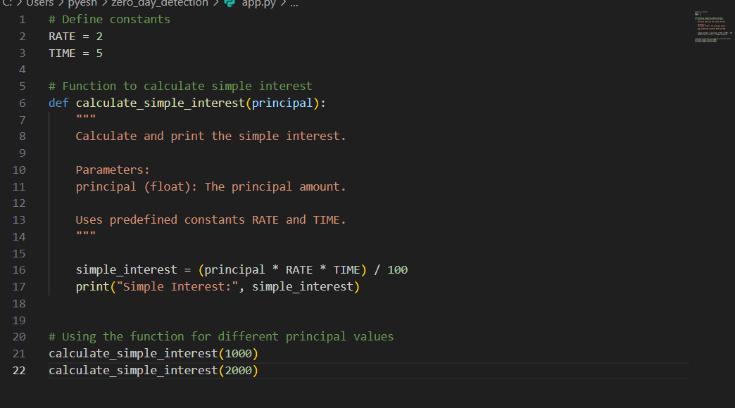

OUTPUT:-

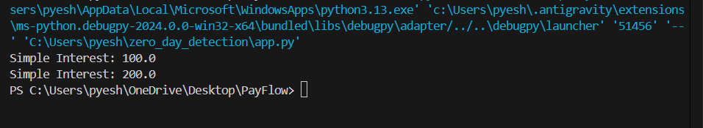

Explanation
In the original program, numeric values like 2 and 5 are directly written in the formula. These are called hardcoded values.
Hardcoded values make programs harder to update and understand.
To improve maintainability:
- Constants RATE and TIME are defined at the beginning of the program.
- The simple interest formula now uses these constants instead of raw numbers.
- A function is used to calculate interest for different principal values.
This makes the code clearer, reusable, and easier to modify.
For example, if the interest rate changes, we only update RATE instead of editing multiple lines.

5. Key Points
- Problem: Hardcoded numbers in calculations.
- Solution: Replace them with named constants.
- Constants used: RATE and TIME.
- Improved readability: Code becomes easier to understand.
- Better maintainability: Changes can be made in one place.
- Program output: Remains exactly the same.

6. Program Logic
- Define constants RATE and TIME at the top of the program.
- Create a function calculate_simple_interest(principal).
- Use the formula:
Simple Interest = (Principal × RATE × TIME) / 100
- Print the calculated interest.
- Call the function with different principal amounts (1000 and 2000).

Task Description -5 (Re factoring – Enhancing Variable Naming
and Code Clarity)
• Task: Apply AI tools to improve code readability by renaming
unclear variables and adding meaningful comments..
Sample Code:
x = 50
y = 30
z = x + y
print(z)

Prompt:- Analyze the given Python code and improve its readability by renaming unclear variables with meaningful names.
Add appropriate inline comments to explain the logic where necessary.
Ensure that the functionality and output of the program remain unchanged.

CODE:-
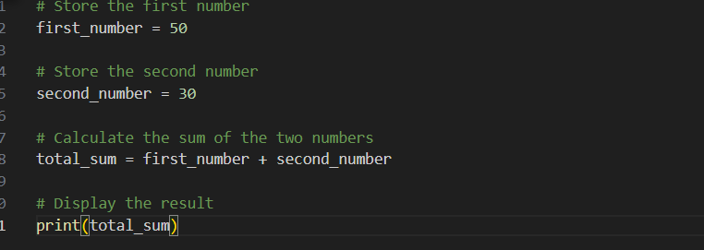

OUTPUT:-

Explanation
The original code uses variables x, y, and z, which are not descriptive and make the program harder to understand.
To improve readability:
- x is renamed to first_number
- y is renamed to second_number
- z is renamed to total_sum
Inline comments are added to explain each step of the program.
These changes make the code easier to read and understand, while the output remains the same.

5. Key Logic
- Store the first value in first_number.
- Store the second value in second_number.
- Add both numbers and store the result in total_sum.
- Print the final result.

